H.T No
Regulations:
A15

Sreenidhi Institute of Science and Technology
(An Autonomous Institution)
Code No: 5C841 Date: 10-Mar-2021 (FN)

B.Tech IV-Year I- Semester External Examination, March/April - 2021 (Supplementary)
CMOS DIGITAL IC DESIGN (ECE)

Time: 3 Hours Max.Marks:75

Note: a) No additional answer sheets will be provided.
b) All sub-parts of a question must be answered at one place only, otherwise it will not be valued.
c) Missing data can be assumed suitably.

ANSWER ANY 5 OUT OF 8 QUESTIONS. EACH QUESTION CARRIES 15 MARKS.

Bloom's Cognitive Levels of Learning (BCLL)

Remember | L1 | Apply | L3 | Evaluate | L5
Understand | L2 | Analyze | L4 | Create | L6

 |  |  | BCLL | CO(s) | Marks
1. | a) | Derive the expression for power dissipation of a CMOS inverter during charging and discharging of a load capacitor. | L4 | CO1 | [8M]
 | b) | For CMOS inverter driving two identical inverters, given 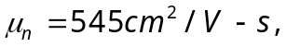 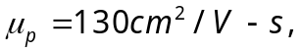 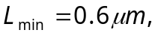and 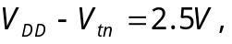find average rise and fall times for 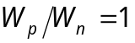. | L4 | CO1 | [7M]
2. | a) | Implement a 1-bit CMOS full adder using AOI circuit logic. | L3 | CO2 | [8M]
 | b) | Realize the Boolean function, y = (A+B)(C+D) using CMOS logic. | L3 | CO2 | [7M]
3. | a) | Analyze the static behavior of two-inverter basic bistable element with help of circuit schematic and voltage transfer characteristic curves of two inverters. | L4 | CO3 | [8M]
 | b) | Draw the circuit structure of the simple CMOS SR latch and discuss the operation modes of the transistors. | L3 | CO3 | [7M]
4. | a) | Briefly examine a dynamic circuit technique for overcoming threshold voltage drops in digital circuits. | L5 | CO4 | [8M]
 | b) | Draw the schematic arrangement of ratioed dynamic logic and explain its shift register logic with shifting process driven by opposite clock phases. | L3 | CO4 | [7M]
5. | a) | Analyze the operation of 4-bit X 4-bit NOR-based ROM array. | L4 | CO5 | [8M]
 | b) | Design a NOR-based row decoder circuit for 2-address bits and 4-word lines. | L3 | CO5 | [7M]
6. | a) | Discuss in detail the structural domain of design abstraction in a Y-chart. | L3 | CO6 | [8M]
 | b) | Describe different stages of verification in VLSI design flow:  - RTL Verification  - Logic Verification  - Layout Verification  - Product Verification | L3 | CO6 | [7M]
7. | a) | Realize the logic circuit of below figure by an NMOS gate  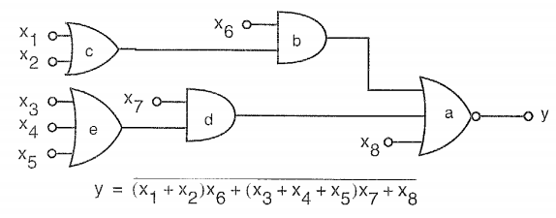 | L4 | CO1 | [5M]
 | b) | Design a transmission gate based XNOR logic. | L3 | CO2 | [5M]
 | c) | Draw the schematic view and the corresponding timing diagram of the CMOS D-latch circuit, showing the set-up time and the hold-time. | L3 | CO3 | [5M]
8. | a) | Draw the schematic of Cascaded domino CMOS logic gates and explain its operation in pre-charge phase and evaluation phase. | L3 | CO4 | [5M]
 | b) | Implement a circuit topology of 1-bit resistive-load based SRAM cell. | L3 | CO5 | [5M]
 | c) | Describe the tradeoffs between design and manufacturing costs for ICs of similar complexity. | L3 | CO6 | [5M]

-- 00 -- 00 –

